**LAB SESSION # 11**

* **TASK : 1**

**Write a program that inputs marks of 5 subjects of a student and calculate its average and grade in functions**

1. **Calculate average**
2. **Show grade :**

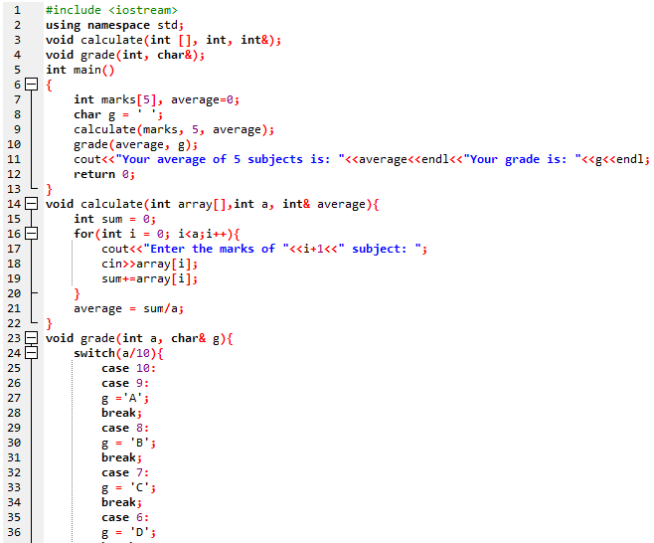

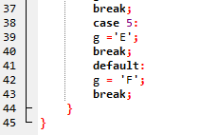

**After compilation :**

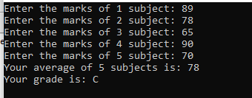

* **TASK : 2**

**Write a program that search the column vise smallest element in a 2-D array :**

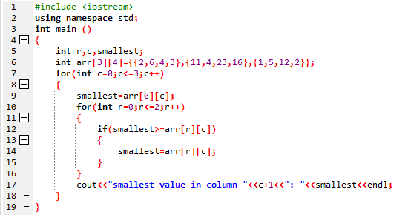

After compilation :

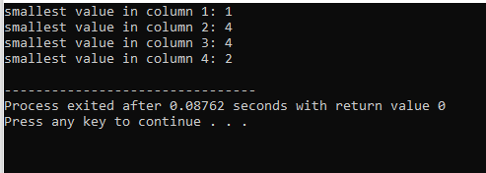

**LAB SESSION # 12**

**TASK # 01:**

**Write a program that will search a name from array of strings using linear search function.**

**SOLUTION:**

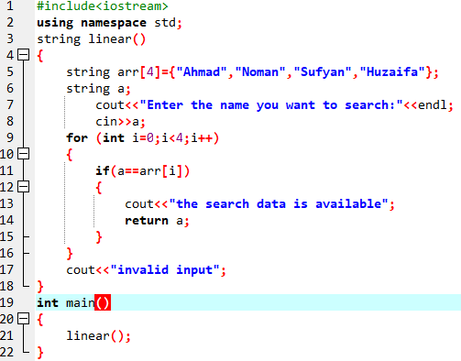

After compilation :

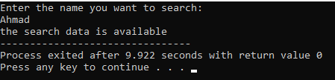

**TASK # 02:**

**Write a program to sort given numeric data of an array.**

